**The Photoelectric Effect – Investigation In-Class Validation**

Time: 50 min

Materials: Pen, pencil, ruler, eraser, calculator and the Formulae and Data sheet

The diagram below shows the experimental setup for the photoelectric effect.

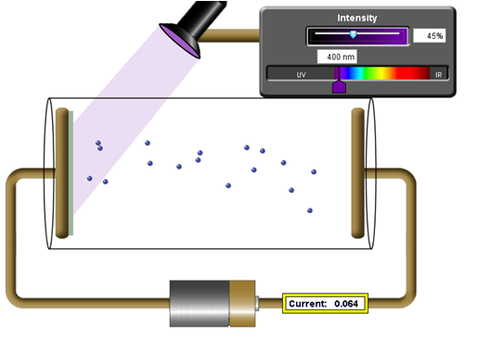

1. In the diagram on the left, the external emf source is applying a very small positive voltage. Which direction are the photoelectrons moving within the vacuum chamber?

[1 mark] [1 mark]

*To the right.* ✓

1. How swill **both** the **kinetic energy** andthe **number** of photoelectrons detected change as:

a) the wavelength of the light is increased [3 marks]

*KE decreases until threshold reached,* ✓ *then nothing* ✓

*Number reaching other side decreases* ✓

b) The intensity is increased [2 marks]

*KE unchanged* ✓

*Number increases* ✓

3. Consider this graph from the above set-up.

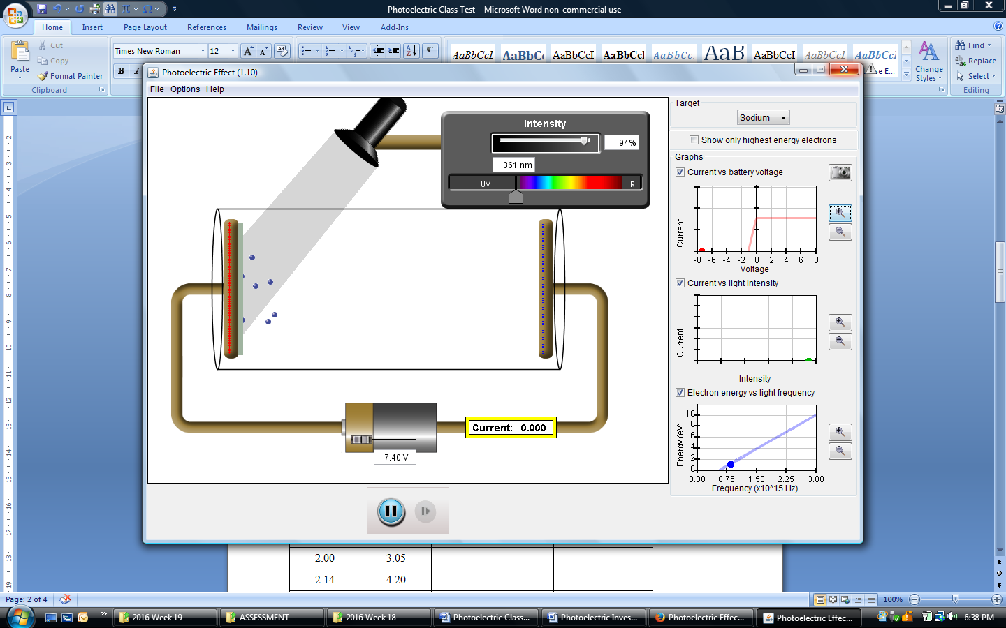a) Estimate the stopping voltage from the graph [1mark]

*Accept 1.1V to 1.5V* ✓

b) Calculate , the maximum energy that electrons have when they leave the plate. [2 marks]

✓

✓

c) Explain what is happening on the section of the graph that has a non-zero gradient. [1 mark]

*As the reverse voltage is reduced, more and more electrons are able to make it across* ✓

d) Explain what is happening on the non-zero horizontal section of the graph. [1 mark]

*Once a positive voltage is applied, all of the photoelectrons make it across.* ✓

4.Describe a graphical method to determine the work function of the metal. Be sure to include any adjustments made to the experimental setup and any calculations required. [4 marks]

*We know* ✓

*For several frequencies (or wavelengths) we could find the stopping voltage by increasing the reverse voltage just to the point where no electrons make it to the plate.* ✓

*Now where V is the stopping voltage.* ✓

*We could then calculate*

*Plot Emax vs frequency and the y-intercept will be W* ✓

A range of frequencies of light were shone onto an unknown metal and the stopping voltages recorded.

|  |  |  |  |
| --- | --- | --- | --- |
| Frequency (×1015 Hz) | Stopping Voltage (V) | Maximum Kinetic Energy (J) | Kinetic Energy Uncertainty (±12%) |
| 1.30 | 0.600 |  |  |
| 1.50 | 1.50 |  |  |
| 1.67 | 2.10 |  |  |
| 2.00 | 2.95 |  |  |
| 2.14 | 4.10 |  |  |
| 2.50 | 5.55 |  |  |

1. Calculate the maximum kinetic energy **in Joules** of the photoelectrons and insert these values into the table above. Some have been done for you. Assume that the maximum kinetic energy values you have calculated have a 12.0 % uncertainty and include this in your table as well.

[3 marks]

*Subtract marks for SF or precision inconsistencies.*

1. Make a plot of maximum kinetic energy (in Joules) against frequency of the incident light in the graph area below. Include error bars in your plot. [10 marks]



Potassium

•

•

•

•

•

•

Frequency (Hz)

1.0 2.0

10

8

6

4

2

-2

-4

-6

0

1. What is the work function of the metal used in this experiment? Explain how you determined this answer. [3 marks]

Approx providing method good. ✓✓

From y-intercept ✓

1. Calculate the gradient of the line of best fit. Include the units. [4 marks]

Construction Lines drawn ✓

✓

JHz-1 ✓✓

1. Show using relevant formula how the gradient of this graph can be used to experimentally determine the value of Planck’s constant. [2 marks]

✓

*The gradient is h.* ✓

1. Potassium has a 2.30 eV work function. Sketch the relationship between kinetic energy and frequency of the light on the same graph axes used in question 6 when potassium is the target metal. Clearly label this line.

[2 marks]

*Correct y-intercept. ✓*

*Parallel to first line. ✓*

**End of Test**